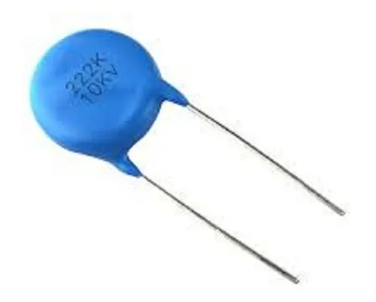
Ceramic Disc Capacitor – 222K / 10KV
Concept – Ye kya hota hai?
Ye ek non-polar high-voltage ceramic capacitor hota hai jo
noise, spike aur high-frequency ripple ko filter karne ke kaam aata hai.
3️⃣ Use Case + Connection Syntax
🔹 Kaha lagate hain?
- SMPS primary snubber section
- Flyback transformer ke across
- MOSFET / diode ke parallel
Note: High-voltage spikes ko absorb karta hai.

